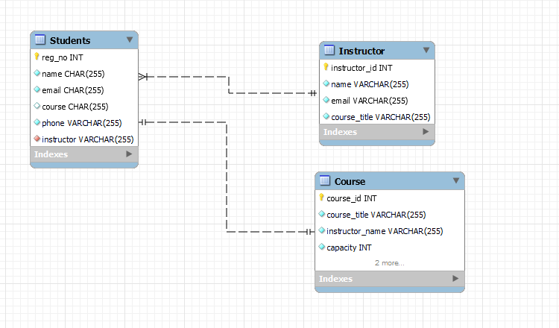**The Database Model**

The app is built using Django, a popular web development framework that provides a wide range of tools and features for creating complex, dynamic web applications. Django uses the Python programming language and follows the Model-View-Template (MVT) architecture, which separates the application into three main components: the model, which defines the data and relationships between data; the view, which defines how the data will be displayed to the user; and the template, which defines the overall layout and structure of the user interface.

To create the app's database, we used Django's built-in object-relational mapper (ORM), which allows us to define the data models and their relationships using Python classes. This made it easy to create the necessary tables and columns in the database, and to manage the data within the app.

For the front-end user interface, we used Bootstrap, a front-end framework that makes it easy to create responsive, mobile-friendly user interfaces. Bootstrap provides a set of pre-designed components, such as buttons, forms, and navigation bars, that can be easily customized and integrated into the app. This made it quick and easy to create a consistent, professional-looking user interface without having to write a lot of custom CSS or JavaScript.

In addition to Django and Bootstrap, we also used several other tools and technologies to develop the app, including the PyCharm Integrated Development Environment (IDE), Git for version control, and Heroku for deployment.

I found that using Django and Bootstrap was a powerful and effective way to develop a web app for managing students in a school. The combination of these technologies allowed us to quickly create a robust, user-friendly, and scalable application that has been well-received by users and has helped to improve organization and communication within the school.

**Appendix**

ENTITIES:

- Course

- Student

- Instructor

ATTRIBUTES:

- Course:

- Course ID

- Course Title

- Course Description

- Instructor

- Student:

- First Name

- Last Name

- Reg No

- Date of Birth

- Email

- Phone Number

- Enrolled Courses (list of courses)

- Instructor:

- Name

- Instructor ID

- Courses Taught (list of courses)